MedTrack DV
Hospital Operations & Patient Analytics Dashboard
Final Project Documentation

Prepared by:
Jabba L N V Lohith

Contents
1. Executive Summary
2. Project Introduction
3. Project Objectives
4. Project Scope
5. Dataset Sources
6. Dataset Structure
7. Data Collection
8. Data Cleaning and Processing
9. KPI Engineering
10. KPI Definitions
11. Dashboard Architecture
12. Hospital Overview Dashboard
13. Patient Flow Dashboard
14. Department Analytics Dashboard
15. Resource Utilization Dashboard
16. Dashboard Interaction Guide
17. Healthcare Operations Methodology
18. Testing and Validation
19. Project Structure
20. Technology Stack
21. Project Delivery
22. Evaluation Criteria
23. Project Outcomes
24. Limitations and Future Improvements
25. Conclusion

1. Executive Summary
MedTrack DV is a hospital operations and patient analytics project built to organize hospital-related data and present it through an interactive Tableau dashboard suite. The project takes a prepared healthcare dataset, processes it using Python, and turns it into four dashboards covering hospital-wide operations, patient flow, department performance, and resource utilization.
This document is the final project documentation for Milestone 4: Testing and Delivery. It brings together the project's data preparation, KPI engineering, dashboard development, and testing work into a single reference, describing how MedTrack DV was actually built rather than giving a general overview of healthcare analytics as a subject.
The final dataset contains 45,000 admission records across 58 columns, with no duplicate records and 100% completeness after processing. Seven main KPIs were engineered from this dataset and are presented across four dashboards: Hospital Overview, Patient Flow, Department Analytics, and Resource Utilization. The project was tested and validated before delivery, and no major issues were identified during the final QA cycle.

2. Project Introduction
Hospitals generate a large amount of operational data through day-to-day admissions, discharges, department activity, and bed usage. When this information is spread across raw records, it is difficult to review quickly or compare across time periods and departments. MedTrack DV was developed to address this by organizing a prepared hospital dataset into a set of KPIs and dashboards that can be reviewed without going back to the raw data each time.
The project is an analytics and visualization exercise built on a static, prepared dataset rather than a live hospital system. It reflects the kind of operational review a hospital analytics team might carry out using historical admission records, and the dashboards are designed to support that kind of review across four different operational perspectives.

3. Project Objectives
The main objectives of the MedTrack DV project were:
- Prepare a clean, complete hospital admissions dataset suitable for dashboard development.
- Engineer a set of KPIs that summarise hospital operations, patient flow, and resource use.
- Build an interactive Tableau dashboard suite covering hospital-wide, patient-level, department-level, and resource-level perspectives.
- Test and validate the dashboards and KPIs before final delivery.
- Document the project clearly enough that it could be reviewed or extended by someone outside the original development work.

4. Project Scope
The scope of MedTrack DV covers hospital admissions, patient movement, length of stay, readmission, department performance, bed utilization, hospital capacity, and resource-related analysis, all based on the prepared hospital_raw_data.csv dataset.
The project does not include real-time data feeds, predictive modelling, or separate staff and equipment datasets. Resource-related analysis in the Resource Utilization dashboard is built from the fields available in the main dataset and the capacity logic developed for the project, rather than from dedicated staffing or equipment records.

5. Dataset Sources
The project is based on a single prepared dataset, hospital_raw_data.csv, which contains hospital admission and operational records used throughout the data processing, KPI engineering, and dashboard development stages. This file is the source dataset for the entire project and is stored under the data/raw directory of the project structure, with the processed version stored under data/processed.

6. Dataset Structure
The final processed dataset used for the Tableau dashboards has the following structure:
Property | Value
File name | hospital_raw_data.csv
Total records | 45,000
Total columns | 58
Duplicate records | 0
Final data completeness | 100%
Dataset status | Ready for Tableau
The dataset contains information used across the following areas:
- Patient admissions and admission dates
- Departments and ward types
- Patient stays and length of stay
- Readmission analysis
- Bed utilization and hospital capacity
- Insurance-related information
- Emergency admissions
- Patient movement and department-level analysis

7. Data Collection
Data collection for this project was handled through a Python script (scripts/data_collection.py) that brought the raw hospital dataset into the project structure for processing. From this point, the dataset was worked on entirely within the project's Python and Jupyter notebook environment, with Pandas and NumPy used to review and prepare the data before it was connected to Tableau.

8. Data Cleaning and Processing
Data cleaning and processing were carried out using Python and Pandas, primarily within the hospital_cleaning.ipynb and data_exploration.ipynb notebooks. The main activities during this stage were:
- Reviewing the overall dataset structure and column types
- Checking for missing values across all fields
- Checking for duplicate records
- Cleaning and preparing individual fields for analysis
- Preparing date information and creating date-related fields
- Preparing categorical fields such as department and ward type
- Creating healthcare-related flags for emergency admissions and bed occupancy
- Creating stay categories based on length of stay
- Preparing the fields required for the Tableau connection
- Reviewing the final processed dataset before handoff to Tableau
The table below summarises the outcome of this stage:
Check | Result
Total records | 45,000
Total columns | 58
Duplicate records | 0
Final completeness | 100%
Dataset status | Ready for Tableau

9. KPI Engineering
Once the dataset was cleaned, a set of engineered fields was created to support KPI calculation and dashboard-level analysis. These fields were built in hospital_kpi_engineering.ipynb using Python and Pandas, and several of them were also used directly as the basis for calculated fields inside Tableau. The finalised KPI values were then exported through scripts/generate_hospital_kpis.py into a set of CSV extracts under KPI_Data (covering admissions by month, bed utilization, department admissions, department efficiency, an overall KPI summary, length of stay, occupancy rate, and readmission), which were used alongside the processed dataset when building the Tableau workbook.
The engineered fields created during this stage were:
Field | Purpose
admission_year | Supports yearly analysis
admission_month | Supports monthly analysis
admission_month_number | Supports month ordering in charts
admission_year_month | Supports combined year-month trend views
admission_quarter | Supports quarterly analysis
emergency_flag | Supports emergency admission analysis
stay_category | Supports patient stay classification
department_revenue | Supports department and revenue-related analysis
disease_load | Supports disease/patient load analysis
bed_occupancy_flag | Supports bed occupancy analysis

10. KPI Definitions
Seven main KPIs were engineered for the project and are used consistently across the dashboard suite.

Total Admissions
The total number of admission records included in the prepared hospital dataset. Project value: 45,000.

Occupancy Rate
Represents hospital capacity occupancy based on the capacity and occupancy logic used in the project. Project value: 100.00%.

Average Length of Stay
The average number of days patients stayed in the hospital across the dataset. Project value: 5.16 days.

Readmission Rate
The percentage of records identified for readmission analysis using the project's readmission logic. Project value: 56.92%.

Bed Utilization Rate
Used to monitor the utilization of available hospital bed capacity. Project value: 100.00%.

Department Efficiency Score
A calculated operational measure used to compare department-level performance using the project's engineered metrics. Project value: 67,291,461.47.

Hospital Total Beds
The hospital capacity figure used in the Resource Utilization dashboard and in capacity planning analysis. The project initially used a capacity of 80 beds; for the final Resource Utilization and capacity analysis, this was updated to 145 beds through the project's calculated-field and capacity logic, rather than by adding individual bed records. Project value: 145 beds.
Where a KPI is described at department level or after a dashboard filter has been applied, the value is filter-dependent and will change with the selection, rather than being a single fixed figure.

11. Dashboard Architecture
The dashboard suite consists of four connected dashboards built in Tableau, each covering a different operational perspective on the same underlying dataset. They are designed to be reviewed in sequence, starting from a hospital-wide summary and moving toward more specific views:
- Hospital Overview – hospital-wide summary and main KPIs
- Patient Flow – admission, discharge, and movement analysis
- Department Analytics – department-level comparison
- Resource Utilization – capacity and resource-related analysis
Filters, parameters, and dashboard actions connect these views so that a selection made on one dashboard can be carried through to related views, supporting the cross-dashboard navigation described later in this document.

12. Hospital Overview Dashboard
The Hospital Overview dashboard provides a high-level summary of hospital operations. It displays Total Admissions, Occupancy Rate, Average Length of Stay, Readmission Rate, and Bed Utilization Rate alongside an admissions overview, occupancy monitoring, readmission analysis, and monthly operational trends.
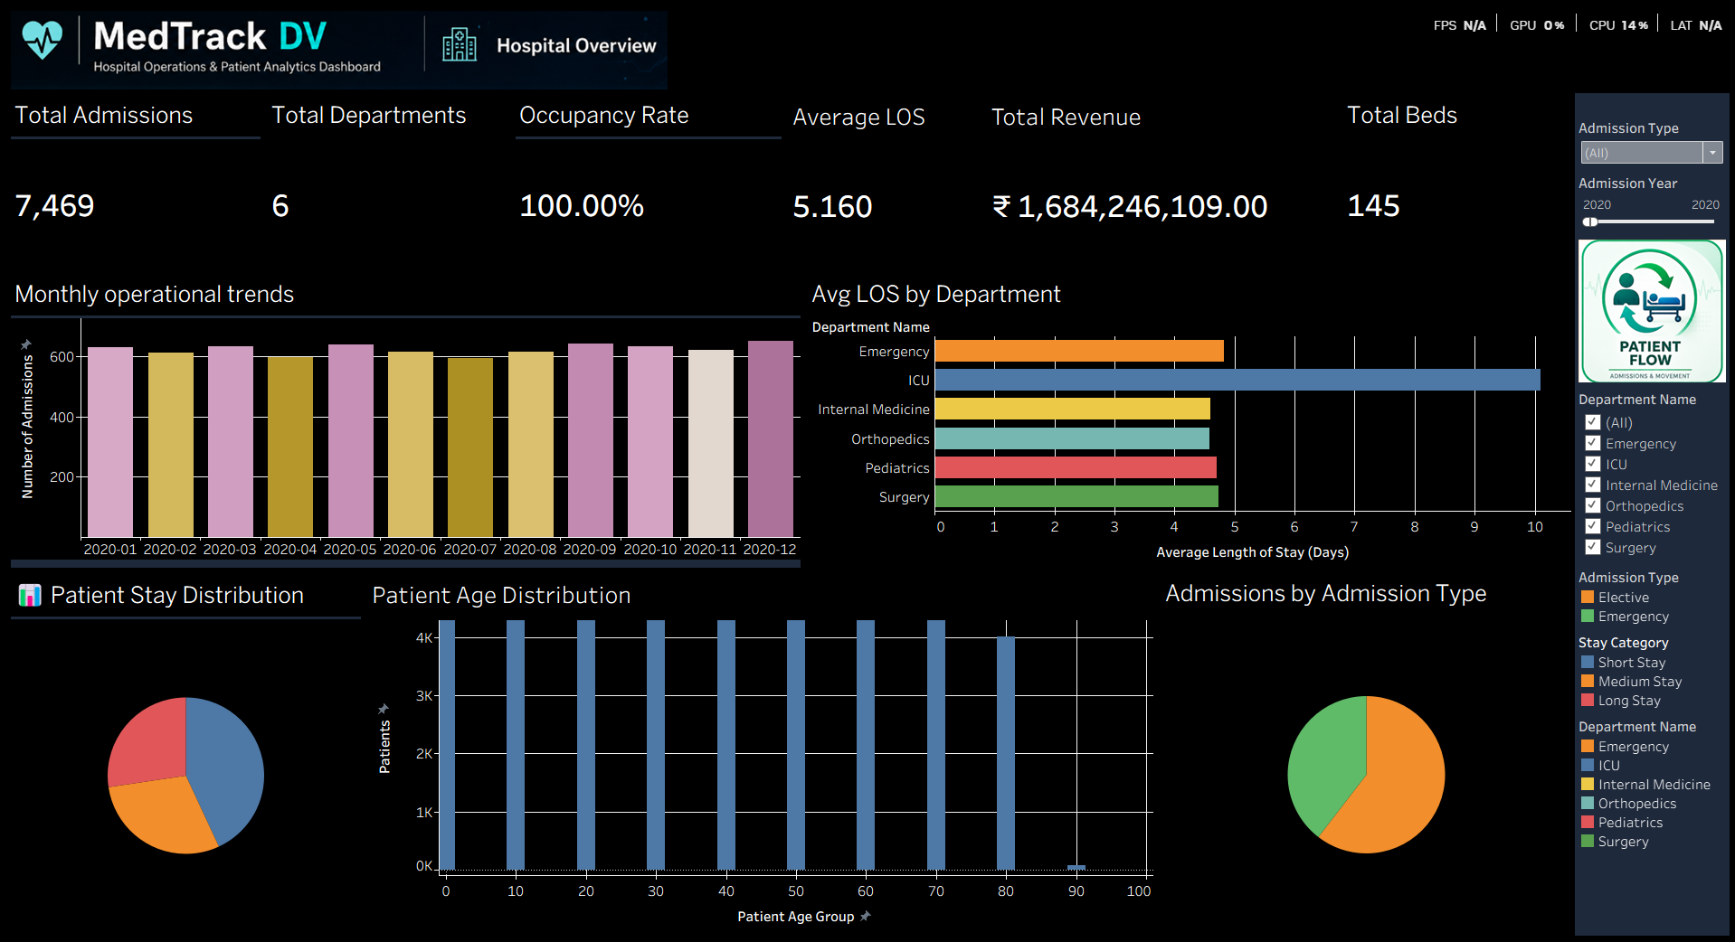
Figure 1: Hospital Overview dashboard
This dashboard is intended as a starting point for the user before moving into the more detailed patient, department, and resource views elsewhere in the workbook.

13. Patient Flow Dashboard
The Patient Flow dashboard focuses on patient movement through the hospital, including admission trends, discharge tracking, patient movement analysis, average stay analysis, peak patient load monitoring, monthly admission trends, and department-level patient flow.
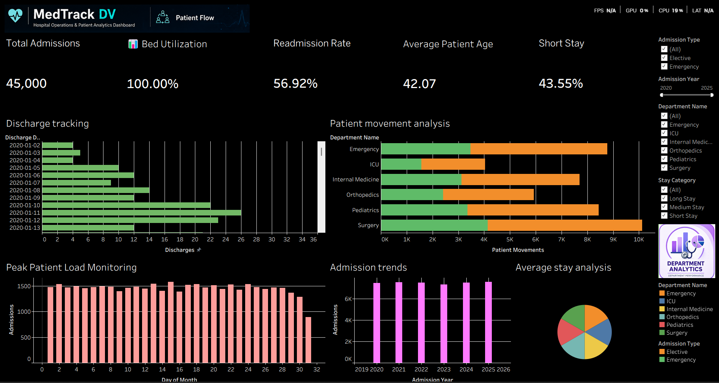
Figure 2: Patient Flow dashboard
This dashboard is built to answer questions such as:
- How many patients are being admitted?
- How does admission activity change over time?
- How does discharge activity compare with admission activity?
- What is the average length of stay?
- When is patient load high?
- How does patient activity vary by department?

14. Department Analytics Dashboard
The Department Analytics dashboard compares patient activity and operational performance across hospital departments, using department performance analysis, patient volume by department, readmission by department, department efficiency comparison, treatment capacity analysis, and department-level KPI comparison.
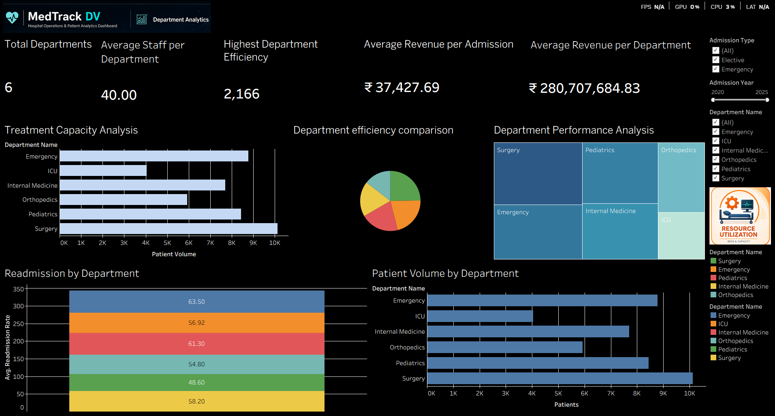
Figure 3: Department Analytics dashboard
This dashboard supports questions such as:
- Which departments handle more patients?
- How does readmission vary across departments?
- How do departments compare in operational performance?
- Which departments have higher patient loads?
- How does department activity relate to treatment capacity?

15. Resource Utilization Dashboard
The Resource Utilization dashboard focuses on hospital capacity and resource-related analysis, including bed utilization analysis, staff allocation monitoring, equipment utilization tracking, capacity planning insights, resource availability analysis, and hospital bed capacity.
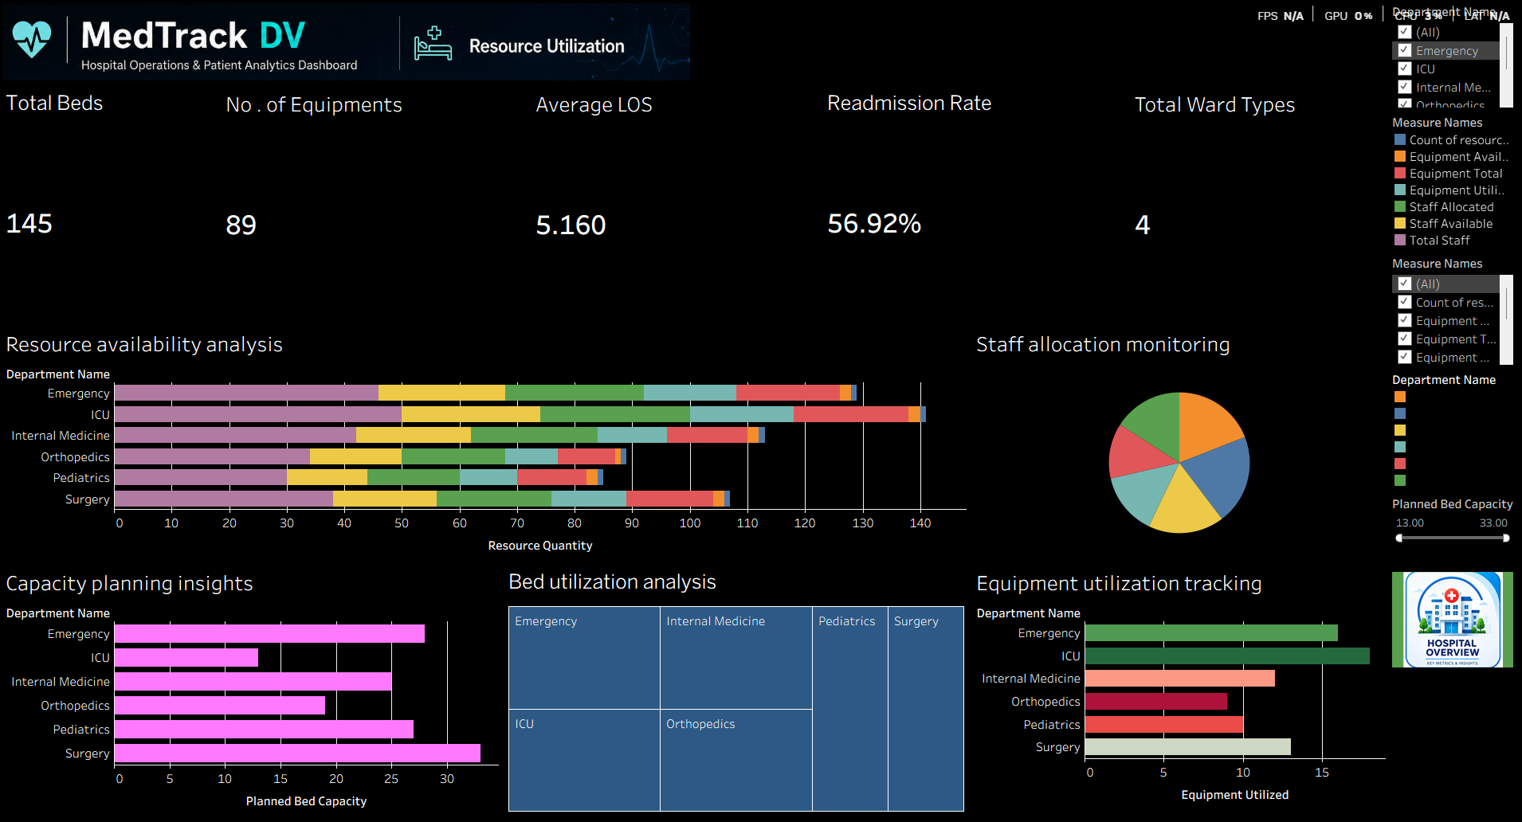
Figure 4: Resource Utilization dashboard
There are no separate original staff and equipment CSV files in this project. The staff- and equipment-related views on this dashboard are built from the resource-utilization analysis available in the project's dataset and calculated or derived fields, rather than from separately collected or imported staffing or equipment datasets.

16. Dashboard Interaction Guide
The recommended flow through the dashboard suite is Hospital Overview, then Patient Flow, then Department Analytics, then Resource Utilization.

Step 1: Hospital Overview
Start here to review the main hospital KPIs and get an overall picture of hospital operations.

Step 2: Patient Flow
Move here to examine admissions, discharges, patient movement, and length of stay in more detail.

Step 3: Department Analytics
Move here to compare departments against one another using the department-level KPIs and visuals.

Step 4: Resource Utilization
Move here to review capacity and resource-related information, including bed utilization and hospital capacity.

17. Healthcare Operations Methodology
The analytical approach used in MedTrack DV follows a fairly standard operational review pattern for hospital data: start from the overall numbers, then narrow down by patient movement, by department, and finally by resource capacity. Each dashboard in the suite maps onto one stage of this pattern, which is why the dashboards are designed to be used in sequence rather than independently.
Readmission and length-of-stay figures are treated as core operational indicators throughout the project, since they appear on more than one dashboard and are used to cross-check consistency between the hospital-wide view and the department-level view. Bed and capacity figures are handled similarly, tying the Hospital Overview and Resource Utilization dashboards together.

18. Testing and Validation
Testing and validation for MedTrack DV were carried out as a dedicated stage after dashboard development was complete, and are documented in full in the separate QA Checklist and Dashboard Testing Report. The summary below reflects the outcome of that work.
QA Area | Result
Dataset validation | Passed
Data completeness | 100%
Duplicate check | Passed
KPI validation | Passed
Healthcare metric validation | Passed
Hospital Overview | Passed
Patient Flow | Passed
Department Analytics | Passed
Resource Utilization | Passed
Dashboard interaction testing | Passed
Patient Flow validation | Passed
Cross-dashboard consistency | Passed
Visual/usability testing | Passed
Major dashboard issues | None
KPI accuracy | Above 95%
Overall QA status | Passed
Testing covered the dataset, the seven KPIs, all four dashboards, dashboard interactions such as filters and navigation, patient flow validation, cross-dashboard consistency, and visual and usability review. No major dashboard issues were identified, and the project was considered suitable for final delivery.

19. Project Structure
The MedTrack DV project follows the folder structure below:
MedTrack_DV/
├── data/
│ ├── raw/
│ ├── cleaned/
│ └── processed/
├── notebooks/
│ ├── data_exploration.ipynb
│ ├── hospital_cleaning.ipynb
│ └── hospital_kpi_engineering.ipynb
├── scripts/
│ ├── data_collection.py
│ └── generate_hospital_kpis.py
├── KPI_Data/
│ ├── Admissions_by_Month.csv
│ ├── Bed_Utilization.csv
│ ├── Department_Admissions.csv
│ ├── Department_Efficiency.csv
│ ├── KPI_Summary.csv
│ ├── Length_of_Stay.csv
│ ├── Occupancy_Rate.csv
│ └── Readmission_Summary.csv
├── tableau/
│ ├── MedTrack_DV/
│ ├── medtrack_prototype.twbx
│ └── dashboard_storyboard.pdf
├── docs/
│ ├── QA Checklist.docx
│ ├── Dashboard Testing Report.docx
│ └── Final Documentation.docx
└── README.md
The data folder separates the raw source file from the cleaned and fully processed versions produced during the notebooks stage. The KPI_Data folder holds the individual KPI extracts (admissions by month, bed utilization, department admissions, department efficiency, a consolidated KPI summary, length of stay, occupancy rate, and readmission summary) generated by scripts/generate_hospital_kpis.py, and these files feed directly into the Tableau workbook. The tableau folder contains the working prototype workbook (medtrack_prototype.twbx), the underlying MedTrack_DV workbook folder, and a PDF storyboard used to plan the dashboard layout before development.

20. Technology Stack
Area | Technology
Data Collection | Python
Data Processing | Pandas, NumPy
Data Cleaning | Python / Pandas
Data Exploration | Jupyter Notebook
KPI Engineering | Python / Tableau Calculations
Visualization | Tableau
Dashboard Development | Tableau Desktop / Tableau Public
Dashboard Interaction | Tableau Filters, Parameters, Actions
Version Control | GitHub
Documentation | Markdown / Microsoft Word

21. Project Delivery
The final deliverables produced for MedTrack DV are:
- Processed healthcare dataset
- Python data-processing scripts
- Jupyter notebooks
- KPI calculations
- Tableau workbook
- Hospital Overview dashboard
- Patient Flow dashboard
- Department Analytics dashboard
- Resource Utilization dashboard
- QA Checklist
- Dashboard Testing Report
- Final Project Documentation
- GitHub repository
- Tableau Public deployment where applicable

22. Evaluation Criteria
The project was evaluated against the milestone requirements below.
Milestone | Evaluation Area | Requirement | Result
Milestone 1 | Data Collection & Cleaning | Dataset completeness > 95% | Achieved
Milestone 2 | KPI Engineering | 6+ KPIs generated | Achieved
Milestone 3 | Dashboard Development | 4 dashboards integrated | Achieved
Milestone 4 | Documentation & Delivery | Portfolio-ready project | Achieved

23. Project Outcomes
The completed project produced the following outcomes:
- A cleaned healthcare dataset containing 45,000 records
- 58 columns, with no duplicate records
- 100% final data completeness
- Six major hospital KPIs, plus additional department and resource measures
- Four integrated Tableau dashboards
- Interactive dashboard filters and controls
- Patient flow analysis, department performance analysis, and bed and capacity analysis
- Resource utilization analysis
- QA validation and dashboard testing
- Final project documentation

24. Limitations and Future Improvements
MedTrack DV is built on a static, prepared dataset rather than a live feed, and it does not include separate staff or equipment datasets, which limits how far the resource-related analysis can go beyond the fields already available in the main dataset. The following are possible future directions for the project and are not implemented in the current version:
- Real-time hospital data integration
- Automated dataset refresh
- Predictive patient admission analysis
- Readmission prediction
- Advanced resource forecasting
- Automated operational alerts
- More detailed staff utilization data
- More detailed equipment-level data
- Integration with live hospital information systems
- Additional forecasting and predictive analytics

25. Conclusion
MedTrack DV takes a prepared hospital dataset through cleaning, KPI engineering, and dashboard development, resulting in a four-dashboard Tableau suite that covers hospital-wide operations, patient flow, department performance, and resource utilization. The dataset was processed to full completeness with no duplicate records, seven KPIs were engineered and validated, and the resulting dashboards were tested for accuracy, interactivity, and cross-dashboard consistency before delivery.
As documented in the accompanying QA Checklist and Dashboard Testing Report, no major issues were identified during final testing. This completes Milestone 4 and brings the MedTrack DV project to a portfolio-ready state, covering the full path from raw hospital data through to a delivered, tested dashboard suite.

